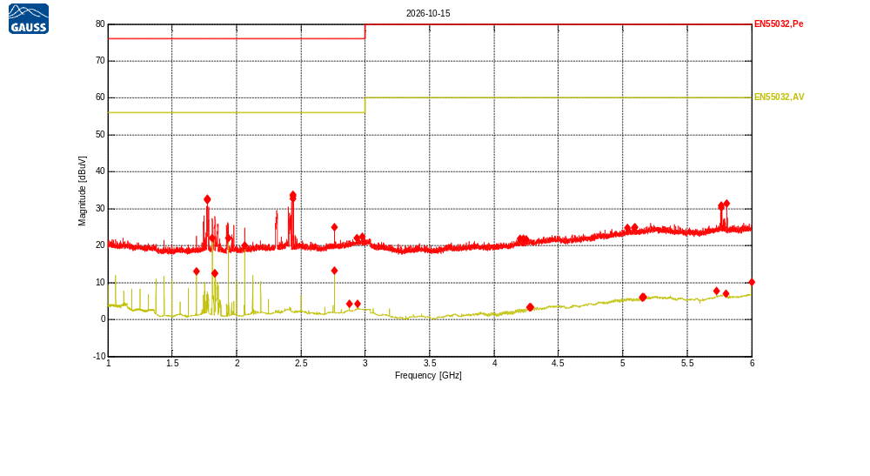
Receiver Model:
Protocol Number:
Serial Number:
Operation State:
Notes:
123123

Traces:
Trace | Start | Step | Stop | IF Bandwidth | Detector | Dwell time | Attenuation | Transducer | LISN | Notes
Scan1 | 1.0 GHz | 500.0 kHz | 6.0 GHz | 1MHz | MaxPeak | 200.0 ms | Auto | TDF1, TDF2 | -
Scan2 | 1.0 GHz | 500.0 kHz | 6.0 GHz | 1MHz | Average | 200.0 ms | Auto | TDF1, TDF2 | -

Transducers:
TDF1: Kabel Biru
TDF2: Heliax_Cable

Limit lines:
EN55032,Pe: EN55032 Rad 3m,Class A,FSOATS, Peak, 1000MHz-6000MHz
EN55032,AV: EN55032 Rad 3m,Class A,FSOATS, AV, 1000MHz-6000MHz
Scan1: 1.0 GHz, 500.0 kHz, 6.0 GHz; IF:1MHz, 200.0 ms MaxPeak, Att AutodB
f | Mag [dBuV] | Limit | Diff | Polarization | Height [cm] | Angle [°] | Trans | Name | Comment
1.77300972 GHz | 32.59 | 76.00 | 43.41 | V | 100 | 0 | 3.42 | EN55032,Pe
1.77418153 GHz | 32.78 | 76.00 | 43.22 | V | 100 | 0 | 3.43 | EN55032,Pe
1.77535335 GHz | 32.35 | 76.00 | 43.65 | V | 100 | 0 | 3.43 | EN55032,Pe
2.43938393 GHz | 33.38 | 76.00 | 42.62 | V | 100 | 0 | 4.14 | EN55032,Pe
2.44055575 GHz | 33.84 | 76.00 | 42.16 | V | 100 | 0 | 4.14 | EN55032,Pe
2.44133696 GHz | 32.75 | 76.00 | 43.25 | V | 100 | 0 | 4.14 | EN55032,Pe
2.76007164 GHz | 25.01 | 76.00 | 50.99 | V | 100 | 0 | 4.44 | EN55032,Pe
2.93506323 GHz | 22.00 | 76.00 | 54.00 | V | 100 | 0 | 4.61 | EN55032,Pe
2.97881113 GHz | 22.38 | 76.00 | 53.62 | H | 400 | 0 | 4.66 | EN55032,Pe
4.20179921 GHz | 21.81 | 80.00 | 58.19 | H | 100 | 180 | 5.99 | EN55032,Pe
4.22679801 GHz | 21.81 | 80.00 | 58.19 | H | 400 | 0 | 6.02 | EN55032,Pe
4.24828135 GHz | 21.74 | 80.00 | 58.26 | H | 400 | 0 | 6.04 | EN55032,Pe
5.03886835 GHz | 24.79 | 80.00 | 55.21 | V | 100 | 0 | 6.80 | EN55032,Pe
5.08964716 GHz | 24.82 | 80.00 | 55.18 | V | 100 | 0 | 6.85 | EN55032,Pe
5.09277201 GHz | 25.07 | 80.00 | 54.93 | H | 100 | 165 | 6.85 | EN55032,Pe
5.76266168 GHz | 30.84 | 80.00 | 49.16 | V | 100 | 0 | 7.37 | EN55032,Pe
5.76734896 GHz | 30.30 | 80.00 | 49.70 | V | 100 | 0 | 7.37 | EN55032,Pe
5.8075814 GHz | 31.41 | 80.00 | 48.59 | H | 100 | 75 | 7.41 | EN55032,Pe

Scan2: 1.0 GHz, 500.0 kHz, 6.0 GHz; IF:1MHz, 200.0 ms Average, Att AutodB
f | Mag [dBuV] | Limit | Diff | Polarization | Height [cm] | Angle [°] | Trans | Name | Comment
1.68785756 GHz | 13.01 | 56.00 | 42.99 | H | 100 | 195 | 3.32 | EN55032,AV
1.81285155 GHz | 22.03 | 56.00 | 33.97 | H | 100 | 90 | 3.47 | EN55032,AV
1.83238186 GHz | 12.52 | 56.00 | 43.48 | V | 100 | 0 | 3.50 | EN55032,AV
1.83355368 GHz | 12.41 | 56.00 | 43.59 | V | 100 | 0 | 3.50 | EN55032,AV
1.93784554 GHz | 21.97 | 56.00 | 34.03 | H | 100 | 240 | 3.62 | EN55032,AV
2.06283953 GHz | 20.07 | 56.00 | 35.93 | H | 100 | 195 | 3.76 | EN55032,AV
2.76007164 GHz | 13.24 | 56.00 | 42.76 | V | 100 | 0 | 4.44 | EN55032,AV
2.87569108 GHz | 4.27 | 56.00 | 51.73 | H | 100 | 210 | 4.56 | EN55032,AV
2.93818808 GHz | 4.25 | 56.00 | 51.75 | H | 100 | 150 | 4.62 | EN55032,AV
4.27874864 GHz | 3.24 | 60.00 | 56.76 | H | 100 | 150 | 6.07 | EN55032,AV
4.27952985 GHz | 3.29 | 60.00 | 56.71 | H | 100 | 120 | 6.07 | EN55032,AV
4.28851379 GHz | 3.28 | 60.00 | 56.72 | H | 100 | 90 | 6.08 | EN55032,AV
5.15175355 GHz | 5.93 | 60.00 | 54.07 | H | 100 | 90 | 6.90 | EN55032,AV
5.15292537 GHz | 5.98 | 60.00 | 54.02 | H | 100 | 90 | 6.90 | EN55032,AV
5.1615187 GHz | 6.09 | 60.00 | 53.91 | H | 100 | 165 | 6.91 | EN55032,AV
5.73024136 GHz | 7.63 | 60.00 | 52.37 | H | 100 | 150 | 7.35 | EN55032,AV
5.79976927 GHz | 6.93 | 60.00 | 53.07 | H | 100 | 90 | 7.40 | EN55032,AV
6 GHz | 10.08 | 60.00 | 49.92 | H | 100 | 150 | 7.56 | EN55032,AV

